UML Exercises 2

1. Suppose you’re designing a toaster. Create a state diagram that tracks the states of bread

in the toaster. Include necessary triggering events. Actions, and guard conditions. (5 points)

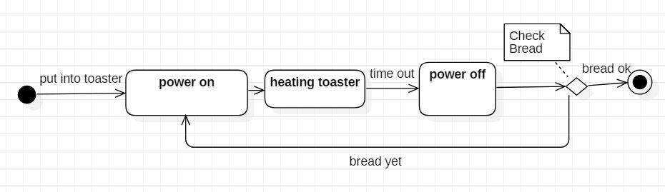

2. Create a sequence diagram for an electric pencil sharpener. Include as objects the user, the

pencil, the insertion point (that is, the place where you put the pencil into the sharpener),

the motor, and the sharpening element. (5 points)

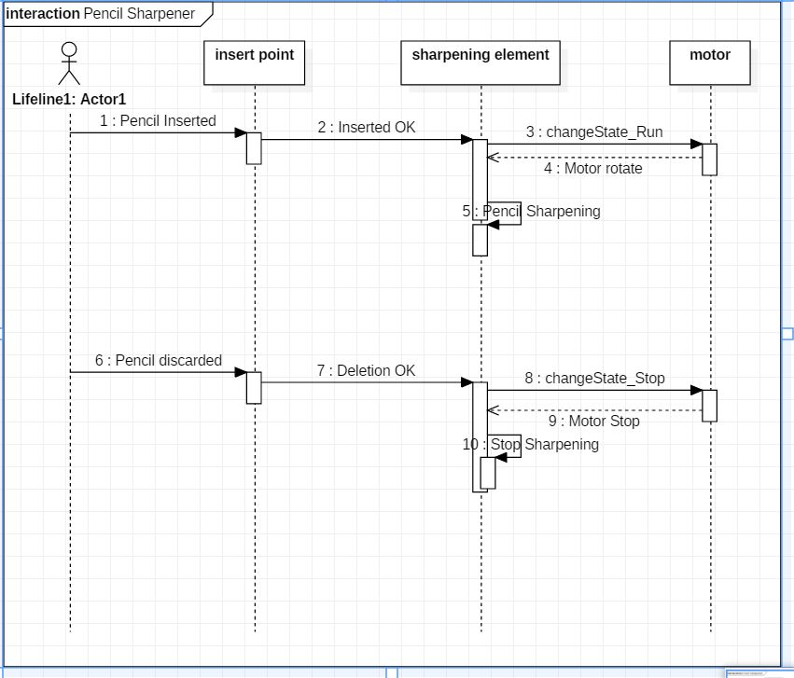

3. Create an activity diagram that shows the process you go through when you start your car.

Begin with putting the key in the ignition, end with the engine running, and consider the

activities you perform if the engine doesn’t start immediately. (5 points)

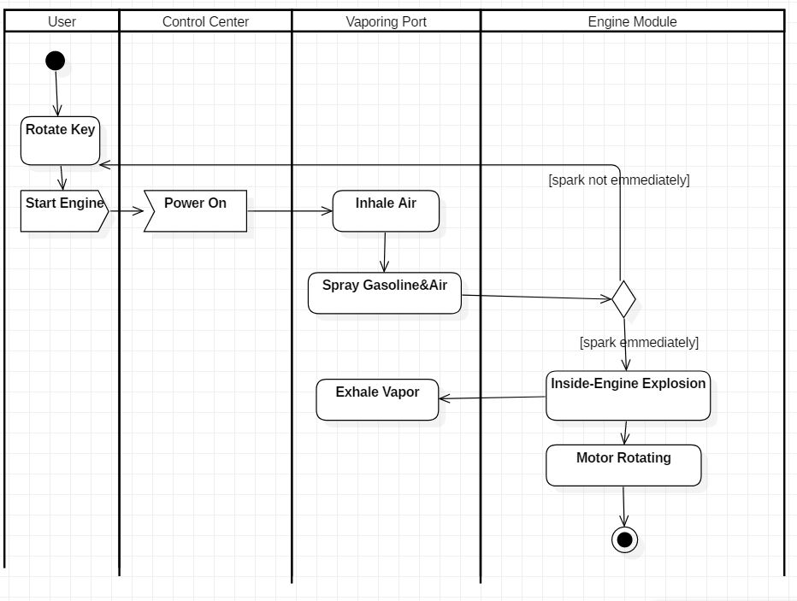

4. Consider your home computer system to be a set of nodes. Draw a deployment diagram

that includes your CPU box and peripherals. Include artifacts. (5 points)

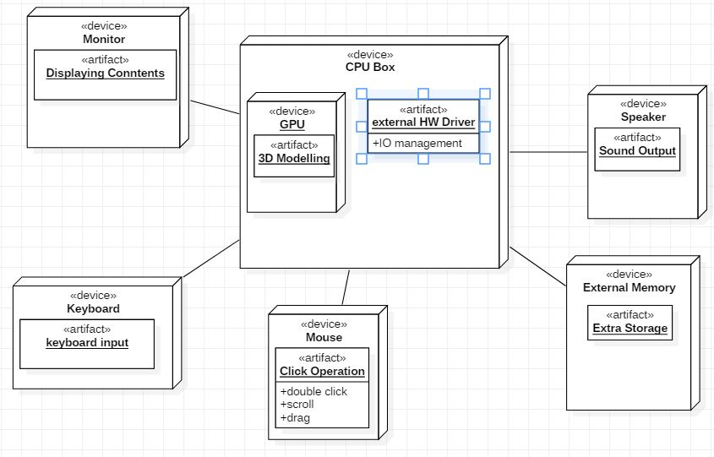

5. Create a sequence and activity diagram for the following collaboration. (10 points)

<Sequence Diagram>

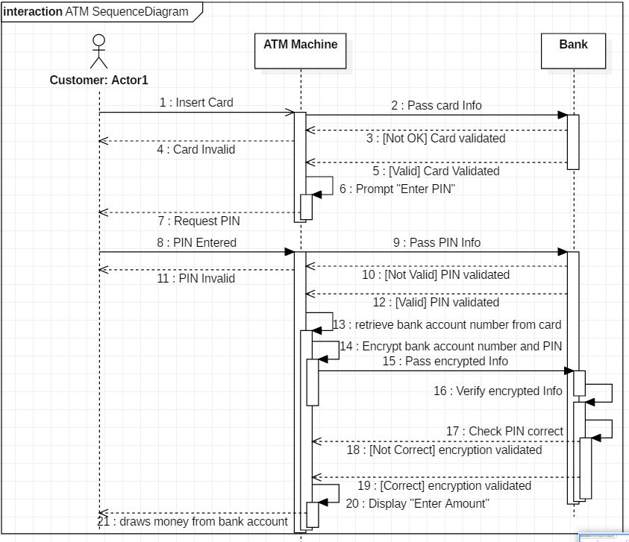

<Activity Diagram>

